Overview

For

General Purpose Research Simulator (GPRS)

Huanquan Pan
Hui Cao*

Last updating: April 2006

SUPRI-B Industrial Consortium
Department of Petroleum Engineering
Stanford University
*now in Schlumberger

Table of Contents

- Introduction 3

- Design of GPRS 3

- Flow Sequence 8

- Sub-directories and Files 10

- Libraries 18

References 19

1. Introduction

GPRS (General Purpose Research Simulator) is a multiple purpose research simulator which incorporates all techniques of modern reservoir simulations. GPRS has a large variety of options and can be used to answer important questions about reservoir engineering and management. GPRS has been widely used in our department, member companies of SUPRI-B industrial affiliates and other institutions.

Currently GPRS has the following main features:
- Fluid model: black oil or compositional fluid
- Grid: structured and unstructured
- Variables: natural variables or overall variables
- Discretization: two-point and multiple point flux
- Implicit level: FIM, IMPES and AIM
- linear solver: direct Lapack solvers and several iterative linear solvers with many different pre-conditioners
- Well model: standard, multiple segments with chokes and drift-flux wellbore flow model

GPRS uses object–oriented design and programming with standard C++. GPRS is a big and complex program, currently it includes hundreds of files, which are separated into many sub-directories. GPRS has multiple developers and its functionalities have grown very fast. In order to facilitate the development and use of GPRS, good documentation is essential.

In order for a developer to quickly understand the basic structure of GPRS, we provide the overview of GPRS design and class relations. The detailed algorithms and techniques are described in Dr. Hui Cao’s Ph.D. dissertation¹ and several released technical reports. To understand the GPRS C++ software, one needs to refer to the API (Application Programming Interface) documents which are generated by doxygen. We provided the HTML format of API documents in the GPRS release package. Finally GPRS has a lot of internal comments, which should be very helpful in understanding individual classes and methods.
We will first explore the design (system models) of GPRS level by level, from top down, after that we will discuss GPRS’s flow sequence.

2. Design of GPRS

The system model shows the basic classes and their relations, and it is very helpful for the understanding of the structure of GPRS. Since GPRS is a complex code, it will be difficult to explain the system model using only one figure. To make it easier to understand, we will show the system models level by level, and explain each level in detail. Figure 1 shows top level (field level) system model for GPRS, which consists of the reservoir object, facilities object, and Simmaster object (note that the Figure 1 is a class diagram using UML (unified model language) notations. UML has been widely used and you should be able to find its notations in any object-oriented software (C++, Java) textbook. The M. Flower book² is very good to learn UML quickly). Simmaster owns two objects: equation selector and linear solver and shares reservoir and facilities objects with field.

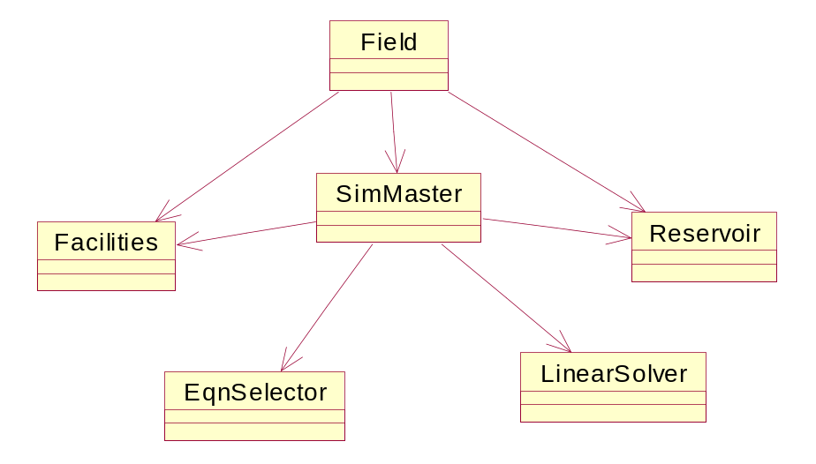
Figure 1 Field level system model

The SimMaster level system model is shown in Figure 2. Basically, in GPRS, the Jacobian matrices are calculated separately for the reservoir part and for the facilities part, the equation selector is used to recast the Jacobian with desired variables and implicit levels. After that the Jacobian matrices are passed to the linear solver and pieced together there for the linear solve. Finally, the solution goes back in the opposite direction. All of these procedures are controlled by SimMaster.

SimMaster
EqnSelector
1) switch variables
2) full set to primary set
3) reduce implicit level
Reservoir
1) calc props
2) calc Jac and RHS
LinearSolver
1) solve AX=B
Faculities
1) calc Jac and RHS

Figure 2 Simmaster level system model

As mentioned above, the Jacobian matrices are calculated separately for the reservoir part and for the facilities part. Figure 3 and Figure 4 show the system model for each of them. From Figure 3, we can see that, each reservoir includes a grid and a formulation, grid part generates the grid information and passes it to the formulation part. The formulation part calculates the gridblock properties and builds the reservoir part of the Jacobian matrix and the RHS. In GPRS, the grid information is either internally generated (currently only for Cartesian grid), or read in from the output of a gridding software. The system model for the well part has a similar structure (as shown in Figure 5). In this part, well information is generated from the well completion data and passed to the well control module, which calculates the well part of the Jacobian matrix and the RHS. Currently, four types of well controls are implemented, and they are BHP, oil flow rate at standard conditions, gas flow rate at standard conditions and water flow rate at standard conditions control.

Reservoir
Grid
Grid information
Formulation
Cartesian
Input from gridding software

Figure 3 Reservoir level system model

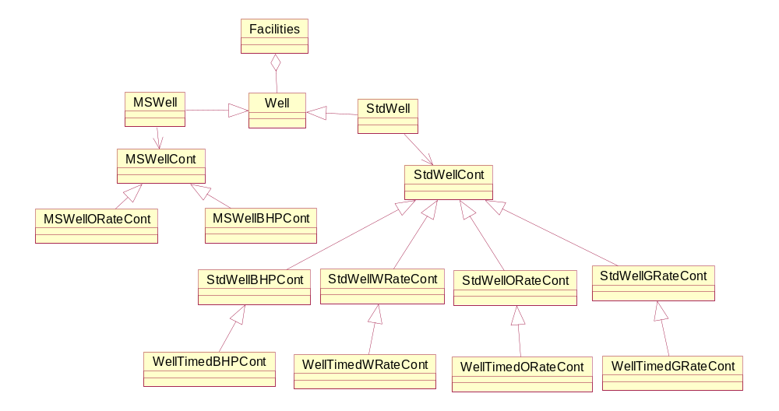

Figure 4 Facility level system model

Well
Well Completion
Well Controls
Well Information

Figure 5 Well level system model

Figure 6 shows the last system model. The entire reservoir related calculations are carried out here. The calculations are organized using five mathematical modules: one for rock, one for fluid, one for rock/fluid, one for phase mobility and the last one for flow equations. Most of the gridblock properties are calculated in the first four modules, and the reservoir part of the Jacobian matrix and the RHS are calculated and assembled in the last module. If necessary, each module can have multiple subclasses for different models. For example the fluid part has a black-oil and a compositional module. If a module has connections to the physical world, such as the rock module, it will have a pointer to the corresponding physical object. All of the mathematical modules are organized in a multi-level inheritance structure, they all share the same public interface (methods), and dynamic binding is used to determine the actual objects and methods required during a run.

Formulation
Rock
Module
1) rock comp
Fluid
Module
1) calculate phase properties
RockFluid
Module
1) rela perm
Mobility
Module
1) assemble phase mobility
Flow Eqn
Module
1) calculate and assemble primary part Jac. and RHS
Rock
BOFluid
RockFluid
CompFluid
BO
Fluid
Module
Comp
Fluid
Module
BO
Mobility
Module
Comp
Mobility
Module
BO
Flow Eqn
Module
Comp
Flow Eqn
Module

Figure 6 Formulation level system model

3. Flow Sequence

Having shown the system models and classes used in GPRS, we will now review the flow sequence of GPRS. The essential steps in a simulator are given below³:
- Read input data (problem definition)
- Initialize (allocate data and set initial conditions)
- Start time step calculations
- Initialize with old timestep data
- Start the Newton iteration
- Calculate gridblock properties
- Linearize (calculate and assemble Jacobian and RHS)
- Solve the linear system
- Perform Newton update
- Check convergence, do another Newton iteration if necessary
- Print and plot results at appropriate times
- Increment time and go to Step 3 if ending conditions are not reached
- End when run is complete

The most important step is Step 3, which accounts for over 95% of the simulation time. The implementation of Step 3 in GPRS is as following:

calcInitProps(); // record old timestep values
while(true) { // start Newton iterations
calcProps(); // calculate gridblock properties
linearize(); // calculate and assemble Jacobian and RHS

convF = convergeF(); // check residual convergence
mLinearSolver->solve() // solve the linear system
newtonUpdate(); // newton update
convY = convergeDY(); // check variable change convergence
if(convF && convY) break; // converged
} // end of Newton iterations

Within this step, four methods handle most of the calculations for the reservoir part, and they are: calcInitProp(), calcProp(), linearize() and newtonUpdate(). They have similar structure as that of linearize():

// --- each mathematical module linearizes ---
list<mthModelBase*>::iterator iter1 = mMthModels.begin();
while (iter1 != mMthModels.end()) {
(*iter1)->linearize(dt);
iter1++;
}

// --- each well linearizes ---
vector<Well*>::iterator iter2 = mWells.begin();
while (iter2 != mWells.end()) {
if((*iter2)->wellOpen()) (*iter2)->linearize();
iter2++;
}

Basically, most of the reservoir calculations are performed by these mathematical modules. Since all of these modules are inherited from the same base class, they share the same public interface, we can just loop through them, and let each of them do its work in turn. The only thing we need to take care of is to program the correct public methods (above four methods) for each module. Using this approach, each Newton iteration becomes simple and flexible. If at any time, a new module is needed, we only need to create it, add it to the list of modules, and implement the above four public methods. If any of the above four methods is not necessary for a module, then it will be empty for that module.

4. Sub-directories and Files

Besides the main program (Main.cpp) which is located in the base directory, there are 14 sub-directories. Here we will introduce each of them and the files contained in them. The detailed information should be referred to API documents.

- field

Field.h/cpp: field class

SimMaster.h/cpp: SimMaster class

- fluid Physical fluid

Fluid.h/cpp: fluid base class
Phase.h/cpp: phase base class
Comp.h/cpp: component class
BOFluid.h/cpp: black-oil fluid class, subclass of Fluid
CompFluid.h/cpp: compositional fluid class, subclass of Fluid
BOPhase.h/cpp: black-oil phase class, subclass of Phase
HCPhase.h/cpp: compositional hydrocarbon phase class, subclass of Phase
WaterPhase.h/cpp: compositional water phase class, subclass of Phase
PhaseEquiCalcBase.h/cpp: base class for flash computation
PhaseEquiCalcSSI.h/cpp: class for flash computation using SSI, subclass of PhaseEquiCalcBase
PhaseEquiCalcNewton.h/cpp: class for flash computation using SSI-Newton, subclass of PhaseEquiCalcBase

Tracer.h/cpp: tracer flow class

Tracer2P.h/cpp: tracer flow class for 2P flux

TracerMP.h/cpp: tracer flow class for MP flux

equiDataStruct.h/cpp: structure for equilibrium data of CO2-H2O system

EquiData.h/cpp: class for fast flash of CO2-H2O system

- grid
Grid.h/cpp: grid class
Grid2P.h/cpp: grid class for 2P flux
GridMP.h/cpp: grid class for MP flux

- mth Formulation modules
mthModelBase.h/cpp: base class for all modules

mthRockCompModel.h/cpp: rock compressibility module, subclass of mthModelBase
mthFluidModelBase.h/cpp: base fluid module, subclass of mthModelBase
mthBOFluidModel.h/cpp: black-oil fluid module, subclass of mthFluidModelbase
mthCompFluidModel.h/cpp: compositional fluid module, subclass of mthFluidModelbase
mthRockFluidModel.h/cpp: rock fluid module, subclass of mthModelBase
mthMobilityModel.h/cpp: phase mobility module, subclass of mthModelBase

mthCompMobilityModel.h/cpp: compositional phase mobility module, subclass of mthMobilityModel
mthFlowEqnModel.h/cpp: base flow equation module, subclass of mthModelbase
mthBOFlowEqnModel.h/cpp: black-oil flow equation module, subclass of mthFlowEqnModel
mthCompFlowEqnModel.h/cpp: compositional flow equation module, subclass of mthFlowEqnModel
mthFlowEqnConnImp.h/cpp: base class to implement connection list in FlowEquModel
mthFlowEqnConn2PImp.h/cpp: 2P connection list implementation
mthFlowEqnConnMPImp.h/cpp: MP connection list implementation
mthBOFlowEqnConn2PImp.h/cpp: 2P connection list implementation for BO fluid
mthBOFlowEqnConnMPImp.h/cpp: MP connection list implementation for BO fluid
mthCompFlowEqnConn2PImp.h/cpp: 2P connection list implementation for compositional fluid
mthCompFlowEqnConnMPImp.h/cpp: MP connection list implementation for compositional fluid

- res Reservoir
Reservoir.h/cpp: reservoir class

EqnSelector.h/cpp: equation selector base class

EqnSelectorCoats.h/cpp: variable Type A (Coats’ model) equation selector class, subclass of EqnSelector

EqnSelectorYoung.h/cpp: variable Type B (Young and Stepenson’s model) equation selector class, subclass of EqnSelector

EqnSelectorConnImp.h/cpp: base class to implement connection list in EqnSelector

EqnSelector2PConnImp.h/cpp: implement 2P connection list

EqnSelectorMPConnImp.h/cpp: implement MP connection list

EqnSelectorYoung2PConnImp.h/cpp: implement 2P connection list for variable Type B

EqnSelectorYoungMPConnImp.h/cpp: implement MP connection list for variable Type B

- rock Physical rock
Rock.h/cpp: physical rock class

- rockfluid Physical rock fluid (relative permeability)
RockFluid.h/cpp: physical rock fluid base class
RockFluid2P.h/cpp: physical two-phase rock fluid class, subclass of RockFluid
RockFluid3P.h/cpp: physical three-phase rock fluid class, subclass of RockFluid
KroModel.h/cpp: three-phase relative permeability model
KroSegrModel.h/cpp: Segregation three-phase relative permeability model
KroStoneIModel.h/cpp: Stone I three-phase relative permeability model
Hysteresis.h/cpp: Hysteresis of relative permeability
HysteresisCarlson.h/cpp: Carlson's hysteresis model
HysteresisLand.h/cpp: Land's hysteresis model
HysteresisJerauld.h/cpp: Jerauld's hysteresis model

- sim Simulation constant definition
Comlibs.h: define common included files
EnumDef.h: define structures, Enumerates and constants used in GPRS

- solver Linear solvers
LinearSolverBase.h/cpp: linear solver base class
LapackFullSolver.h/cpp: full matrix solver from LAPACK, subclass of LinearSolverBase
LapackFullSolver2P.h/cpp: Implement 2P connection list for LapackFullSolver
LapackFullSolverMP.h/cpp: Implement MP connection list for LapackFullSolver
LapackBandSolver.h/cpp: band matrix solver from LAPACK, subclass of LinearSolverBase
LapackBandSolver2P.h/cpp: Implement 2P connection list for LapackBandSolver
LapackBandSolverMP.h/cpp: Implement MP connection list for LapackBandSolver
ImlGMRESSolver.h/cpp: GMRES solver from IML (Iterative Math Library), subclass of LinearSolverBase
ImlGMRESSolver2P.h/cpp: Implement 2P connection list for GMRES solver
ImlGMRESSolverMP.h/cpp: Implement MP connection list for GMRES solver
BlitzSolver.h/cpp: solver from BlitzPak, subclass of LinearSolverBase
BlitzSolver2P.h/cpp: Implement 2P connection list for BlitzSolver
BlitzSolverMP.h/cpp: Implement MP connection list for BlitzSolver
BiCGstabSolver2P.h/cpp: BICGSTAB solver from IML with Implementing 2P connection list
BiCGstabSolverMP.h/cpp: BICGSTAB solver from IML with Implementing MP connection list
PreconditionerBase.h/cpp: preconditioner base class
DiagPre.h/cpp: diagonal scaling preconditioner, subclass of PreconditionerBase
BlockDiagPre.h/cpp: block diagonal scaling preconditioner, subclass of PreconditionerBase
ILUPre.h/cpp: Incomplete LU decomposition (ILU0) preconditioner from SparseLib++, subclass of PreconditionerBase
AMGPre.h/cpp: Algebraic Multi-Grid (AMG) preconditioner from GMD software, subclass of PreconditionerBase
TrueIMPESPre.h/cpp: Constraint Pressure Residual (CPR) preconditioner, true IMPES is used to generate the pressure equation, subclass of PreconditionerBase
TrueIMPESPre2P.h/cpp: Implement 2P connection list for TrueIMPESPre preconditioner
TrueIMPESPreMP.h/cpp: Implement MP connection list for TrueIMPESPre preconditioner
QuasiIMPESPre.h/cpp: Constraint Pressure Residual (CPR) preconditioner, quasi IMPES is used to generate the pressure equation, subclass of PreconditionerBase
QuasiIMPESPre2P.h/cpp: Implement 2P connection list for QuasiIMPESPre preconditioner
QuasiIMPESPreMP.h/cpp: Implement MP connection list for QuasiIMPESPre preconditioner
SAMGPre.h/cpp: SAMG preconditioner, subclass of PreconditionerBase
SAMG.h/cpp: header file for SAMG library

- utl Utilities
FileIO.h/cpp: file input and output class
Table.h/cpp: table read in and look up class
Strlib.h/cpp: string operation class
F2Cwrapper.h/cpp: Fortran to C++ wrapper class for Fortran subroutines
MyMatrix.h/cpp: matrix operations class, suitable for small matrix
DataVector.h/cpp: vector of data base class
IntDataVector.h/cpp: vector of integer data class, base class of DataVector
DFDataVector.h/cpp: vector of double data class, base class of DataVector
ConnDataVector2P.h/cpp: vector of 2P connection data class, base class of DataVector
ConnDataVectorMP.h/cpp: vector of MP connection data class, base class of DataVector
DataPool.h/cpp: data pool class, store and provide access to all DataVector objects
- facilities
Facilities.h/cpp: Facilities class to handle wells and surface facilities
Well.h/cpp: base class for well
WellCompl.h.cpp: well completion class

- facilities/mswell
MSWell.h/cpp: multiple segment well class
MSWellCompl.h.cpp: multiple segment well completion class
segment.h.cpp: segment class
HomoSegment.h.cpp: class for homogenous flow model in segment
HomoSegment.h.cpp: class for Draft Flux model in segment
MSWellCont.h/cpp: well control base class for multi-segment well
MSWellBHPCont.h/cpp: well bottom hole pressure (BHP) control class for multi-segment well
MSWellORateCont.h/cpp: well constant oil flow rate control class for multi-segment well

- facilities/stdwell
stdWell.h/cpp: standard well class
stdWellCompl.h.cpp: standard well completion class
stdWellCont.h/cpp: well control base class for standard well
stdWellBHPCont.h/cpp: well bottom hole pressure (BHP) control class for standard well
stdWellORateCont.h/cpp: well constant oil flow rate control class for standard well
stdWellGRateCont.h/cpp: well constant gas flow rate control class for standard well
stdWellWRateCont.h/cpp: well constant water flow rate control class for standard well
stdWellTimedBHPCont.h/cpp: time-dependent well bottom hole pressure (BHP) control class for standard well
stdWellTimedORateCont.h/cpp: time-dependent well constant oil flow rate control class for standard well
stdWellTimedGRateCont.h/cpp: time-dependent well constant gas flow rate control class for standard well
stdWellTimedWRateCont.h/cpp: time-dependent well constant water flow rate control class for standard well

- VLEUtl Utilities for flash computations
gauss.h/cpp: class for solving linear equation using Gauss method
vecmat.h/cpp: class for vector & matrix operation

- DataGen Generate took-up table for fast flash of CO2_H2O mixture
explictFlashImp.h/cpp: driver for flash calculations
unitExpFlash.h/cpp: perform flash calculations

5. Libraries

GPRS uses several public domain libraries, and most of them are used in the linear solver part. They are discussed below:
- STL (Standard Template Library) This library is a popular library that is treated by many as a standard C++ library. In GPRS, we use the “List” and “Vector” template classes from this library.
- LAPACK⁴ (Linear Algebra Package) This is a standard linear algebra package, which can be freely downloaded from www.netlib.org. It has a Fortran version and a C version. Currently we are using the Fortran version, and wrappers are used to interface it with the main C++ code. For most SGI machines, LAPACK is already installed. For PC’s, we use the MKL (Math Kernel Library) from INTEL, which includes LAPACK. In GPRS, we use the direct solvers (dgesv and dgbsv) from LAPACK.
- BlitzPak⁵ This is a commercial solver package from Landmark Graphic Corporation. GPRS interfaces with it, and uses it as a structured grid solver (not available for Windows’ version).
- AMG⁶ This is an Algebraic Multi-Grid (AMG) solver from GMD software⁶, which can be freely downloaded from http://www.mgnet.org/mgnet-codes-gmd.html. It is only used as a preconditioner for the pressure system in GPRS.
- SAMG This is improved version of AMG developed by Fraunhofer Institute for Algorithms and Scientific Computing (SCAI, www.scai.fraunhofer.de/nuso ). To run the library, please contact Tanja Clees (e-mail: tanja.clees@scai.fhg.de) at SCAI to get a temporary license (one month). If you want to continue using it, you may need to pay the license fee.
- SparseLib++⁷ This is a sparse matrices library (freely downloadable from http://math.nist.gov/sparselib++/) which includes some basic representations for sparse matrix, such as compressed row format, and some basic preconditioners, such as ILU0 (Incomplete LU decomposition without fill-in). In GPRS, we use it for sparse matrix representation and ILU0 preconditioner.
- IML⁸ (Iterative Math Library) This is an iterative solver package (freely downloadable from http://math.nist.gov/iml++/), which includes GMRES, CG (Conjugate Gradient), etc. In GPRS, we only use its GMRES solver.

References

- Cao, H.: “Development of Techniques for General Purpose Simulators”, Ph.D. dissertation, Stanford University, June 2002
- Flower, M: “UML Distilled”, 3rd Ed., Addison-Wesley, 2004.
- Aziz, K.: “Fundamentals of Reservoir Simulation”, class notes for PE223 (Reservoir Simulation) class, summer 1996
- Anderson, E., Bai, Z., Bischof, C., Blackford, S., Demmel, J., Dongarra, J., Du Croz, J., Greenbaum, A., Hammarling, S., Mckenny, A. and Sorensen, D.: “LAPACK Users’ Guide, Third Edition”, Society for Industrial and Applied Mathematics, 1999
- Landmark Graphics Corporation: “BlitzPak User’s Guide”, 1998, http://www.lgc.com
- Ritzdorf, H.: “Readme to AMG Package”, GMD Software, 1991
- Pozo, R., Remington, K.A. and Lumsdaine, A.: “SparseLib++ v.1.5, Sparse Matrix Class Library Reference Guide”, National Institute of Standards and Technology, April 1996
- Dongarra, J., Lumsdaine, A., Pozo, R. and Remington, K.A.: “IML++ V.1.2, Iterative Methods Library Reference Guide”, National Institute of Standards and Technology, April 1996

